1. **INTRODUCTION**

Tourism is the act of travel for predominantly recreational or leisure purposes, and also refers to the provision of services in support of this act. According to the World Tourism Organization, tourists are people who "travel to and stay in places outside their usual environment for not more than one consecutive year for leisure, business and other purposes not related to the exercise of an activity remunerated from within the place visited".

Tourism is vital for many countries, due to the income generated by the consumption of goods and services by tourists, the taxes levied on businesses in the tourism industry, and the opportunity for employment and economic advancement by working in the industry. For these reasons NGOs and government agencies may sometimes promote a specific region as a tourist destination, and support the development of a tourism industry in that area. The contemporary phenomenon of mass tourism may sometimes result in overdevelopment, however alternative forms of tourism such as ecotourism seek to avoid such outcomes by pursuing tourism in a sustainable way.

**1.1 Problem of Tour Management :-**

1. Travellers Could not find cheaper rates offline themselves
2. Changing traveller and booker behaviour
3. Access to data
4. Traveller safety

**1.2 Proposed Solution:-**

**1. Travellers could not find cheaper rates offline themselves**

Travellers could not find cheaper rates offline, while dealing with our management they will get to know that the online booking of the tourist place from our website is much cheaper than the offline booking and other travel agencies there are some business travel agents that are embracing the rates made available to the public on Internet sites such as XXXXXX.com and YYYYY.com .

**2. Changing traveller and booker behaviour**

Challenging booking behaviour is a real problem for travel managers, most people know that it makes sense to book in advance to get [cheaper train fares](http://www.clicktravel.com/travel-management-blog/9-ways-to-reduce-your-travel-spend-on-rail-tickets?__hstc=753710.feb4d69bdb84720575f0bc703db5e56a.1456633803247.1456633803247.1456633803247.1&__hssc=753710.1.1456633803247&__hsfp=1443110243) or [air fares](http://www.clicktravel.com/travel-management-blog/13-ways-to-reduce-your-travel-spend-on-air-tickets?__hstc=753710.feb4d69bdb84720575f0bc703db5e56a.1456633803247.1456633803247.1456633803247.1&__hssc=753710.1.1456633803247&__hsfp=1443110243), or that a room in a 3 star hotel is going to be adequate for their stay and cheaper than the 4 star next door. However, we also know that many travellers will book what suits their own personal needs (when it’s in policy), instead of the most cost effective option. This is where the knowledge and skill of the travel management company comes into play, our management booking System constantly remains same and our behaviour towards customer is very polite and respectable. we always concern customer comforts And its need.

**3. Access to data**

Let’s face it, if you haven’t got all your travel data together in one place you’ll be spending valuable time collating it all when you could be working on policy updates or challenging the top out of policy travellers. Quite simply you can’t measure what you can’t see, so by consolidating all your travel spend through one corporate travel agency, you’ll have the ability to quickly and easily see what you’re spending, what you’re spending it on, and who is spending it. Once you have this information, it’s then very easy to see what you need to focus on to make savings against budget.

**4. Ensuring traveller safety**

Customer Safety is our’s first priority , there is no valuable thing than a life . This year alone we have seen various incidents around the world impacting travel, and as a travel manager we have a responsibility to ensure the safety

**1.3 OBJECTIVE**

the aim of our project is to computerize and manage the activities handled in a travels agency. this enable us to keep track of the daily reports which includes the employees availability, vehicle availability, passenger details, collection amount and the condition of vehicles etc, this can be implemented with all type of travels agency which will help to reduce the manual tasks.

**1.4 SCOPE**

We aim to focus on the problems faced by travels when they think of visiting unknown cities. With the help of our team and by analyzing real world problems, we discovered problems concerning the issue. All the problems and solution to them have been included in our project. We try our level best to ease customers hardships during their visit through our portal.

**2 LITERATURE SURVEY**

Tour Management systems applications support the interaction between different parties participating in the travelling platform via the network, as well as the management of the data involved in the process.

Various users can take online Tour Manage for various subject as per interest,and analysis his/her knowladge with globally present information.

One advantage of Tour Management system is that it provide all the information easily to user in just minutes and user can book the place for tourism easily .

**2.1 REQUIREMENT ANALYSIS**

**Introduction : Requirement & Analysis**

Requirement analysis is the most important and fundamental stage in SDLC. It is performed by the senior members of the team with inputs from the customer, the sales department , market surveys and domain expert in the industry. This information is then used to plan the basic project approach and to conduct product feasibility study in the economical , operational, and technical areas.

Planning for the quality assurance requirement and identification of the risks associated with the project is also done in the planning stage. The outcome of the technical feasibility study is to define the various technical approaches that can be followed to implement the project successfully with minimum risks.

Introduction: Tour Management

Tourism is travel for pleasure; also the theory and practice of touring, the business of attracting, accommodating, and entertaining tourists, and the business of operating tours. Tourism may be international, or within the traveler's country.

The system capable of managing Tour resources, working on different platforms and supporting multi language was designed in this project. The implemented system takes advantages from HTML technology. Hence ,making easier to change view of entire system by requesting throught a browser for ASP.NET Web pages.

**3.1.2**  **Requirement Sources :**

Required Information regarding to the project is collected from various different sources , the mainly requirement sources are:

1. End Users
2. Stack holder
3. Experienced developers
4. Experts

**2.2 Requirement Elicitation**

1. **According to End user**

. Status of Tour Management

. Basic idea of tour management regarding user

. Facilities which needs to be provide

. About customer experienced regarding previous tour

**b.** **According to Stack Holder**

. Details of similar popular project

. Get list of expert and customer

1. **According to Experts**

. Software requirement

. Hardware requirement

. Modules requirement

. Extraction of various query from database

. Security of system from intrunders

1. **According to Experienced developers**

. Reason behind success of previous tour project

. Detail analysis of our project.

. Reason behind failure of project if any.

. Necessary Modification in our project

**3 SYSTEM ANALYSIS**

**3.1 PlATFORM SPECIFICATIONS**

**SOFTWARE REQUIREMENT**

Environment : Microsoft Visual studio .Net

Operating System : Windows Family

Language : ASP.NET

Application : Web Application

Front End : ASP.Net

Back End : SQL SERVER

**HARDWARE REQUIREMENT**

Processor : intel i5 core processor

RAM : 1 GB

Hard Disk Drive : 4 GB

Monitor : 17" Color Monitor

**Identification of need**

Current Scenario in Travel agency business is the lack of precious information, at right time to the right person. The system must maintain the information regarding the customer and their booking detail loyal to the firm, since in the present system everything is a manual written statement where the fraudulent activity of the employee’s cannot be found.

This prevailing scenario makes difficult to cope up in making strategic and tactical decisions. More over it also affects over all resource utilization. Scheduling of the trip or arrangement for travel being made prior might be wrong scheduled or committed to some other customer and to other employee of the concern. Assigning of trip to customer, who has been allotted for the customer is not known, where wrong person may misuse the situation.

**3.2 FRONT END AND BACK END**

**ASP.NET**

ASP.NET is the next version of Active Server Pages (ASP); it is a unified Web development platform that provides the services necessary for developers to build enterprise-class Web applications. While ASP.NET is largely syntax compatible, it also provides a new programming model and infrastructure for more secure, scalable, and stable applications.

ASP.NET is a compiled, NET-based environment, we can author applications in any .NET compatible language, including Visual Basic .NET, C#, and JScript .NET. Additionally, the entire .NET Framework is available to any ASP.NET application. Developers can easily access the benefits of these technologies, which include the managed common language runtime environment (CLR), type safety, inheritance, and so on.

ASP.NET has been designed to work seamlessly with WYSIWYG HTML editors and other programming tools, including Microsoft Visual Studio .NET. Not only does this make Web development easier, but it also provides all the benefits that these tools have to offer, including a GUI that developers can use to drop server controls onto a Web page and fully integrated debugging support.

**BACK END**

SQL server has been used in our project as the back end, it is a server query language used to create and manipulate database, therefore, using in our project to maintain communication with the front end.

**PRELIMINARY INVESTIGATION**

We have gone through a very labored work to find out all the vulnerabilities in the present system and work accordingly to propose a long lasting solution to the issue. We arranged to have interactions with the people involved in this system.

**3.3 SYSTEM STUDY**

**FEASIBILTY STUDY**

The feasibility of the project is analyzed in this phase and business proposal is put forth with a very general plan for the project and some cost estimates. During system analysis the feasibility study of the proposed system is to be carried out. This is to ensure that the proposed system is not a burden to the company. For feasibility analysis, some understanding of the major requirements for the system is essential.

The feasibility study investigates the problem and the information needs of the stakeholders. It seeks to determine the resources required to provide an information systems solution, the cost and benefits of such a solution, and the feasibility of such a solution. The analyst conducting the study gathers information using a variety of methods, the most popular of which are:

* Interviewing users, employees, managers, and customers.
* Developing and administering questionnaires to interested stakeholders, such as potential users of the information system.
* Observing or monitoring users of the current system to determine their needs as well as their satisfaction and dissatisfaction with the current system.
* Collecting, examining, and analyzing documents, reports, layouts, procedures, manuals, and any other documentation relating to the operations of the current system.
* Modeling, observing, and simulating the work activities of the current system.

The goal of the feasibility study is to consider alternative information systems solutions, evaluate their feasibility, and propose the alternative most suitable to the organization. The feasibility of a proposed solution is evaluated in terms of its components. These components are:

* ECONOMICAL FEASIBILITY
* TECHNICAL FEASIBILITY
* SOCIAL FEASIBILITY
* OPERATIONAL FEASIBILITY

**ECONOMICAL FEASIBILITY**

This study is carried out to check the economic impact that the system will have on the organization. The amount of fund that the company can pour into the research and development of the system is limited. The expenditures must be justified. Thus the developed system as well within the budget and this was achieved because most of the technologies used are freely available. Only the customized products had to be purchased.

**TECHNICAL FEASIBILITY**

This study is carried out to check the technical feasibility, that is, the technical requirements of the system. Any system developed must not have a high demand on the available technical resources. This will lead to high demands on the available technical resources. This will lead to high demands being placed on the client. The developed system must have a modest requirement, as only minimal or null changes are required for implementing this system.

**SOCIAL FEASIBILITY**

The aspect of study is to check the level of acceptance of the system by the user. This includes the process of training the user to use the system efficiently. The user must not feel threatened by the system, instead must accept it as a necessity.

The level of acceptance by the users solely depends on the methods that are employed to educate the user about the system and to make him familiar with it. His level of confidence must be raised so that he is also able to make some constructive criticism, which is welcomed, as he is the final user of the system.

**OPERATIONAL FEASIBILITY**

The ability, desire, and willingness of the stakeholders to use, support, and operate the proposed computer information system. The stakeholders include management, employees, customers, and suppliers. The stakeholders are interested in systems that are easy to operate, make few, if any, errors, produce the desired information, and fall within the objectives of the organization.

**3.4 OBJECT ORIENTED DESIGN:-**

* Objects
* Classes
* Data Abstraction
* Encapsulation
* Inheritance
* Polymorphism
* Dynamic Binding
* Message Passing

**Objects:-**

Objects are the basic run time entities in an object oriented system. They may represents a person, a place, a bank account, a data table of data or any item that the program has to handle. Objects take up space in the memory and have an associated address like a record in Pascal, or structure in c.

When a program is executed, the objects interact by sending message to one another.

**Classes:-**

The entire set of data and code of an object can be made a user defined data type with the help of a class. In fact, objects are variables of the type class. Once a class has been defined we can create any number of objects belonging to that class. Each object is associated with the data of type class with which they are created. A class is thus a collection of objects of similar type.

**Data Abstraction:-**

Abstraction refers to the act of representing essential features without including the background details or explanations. Classes use the concept of abstraction and are defined as list of abstract attributes such as size, weight, and cost, and functions to operate on these attributes. They encapsulate all the essential properties of the objects that are to be created.

**Encapsulation:-**

The wrapping up of data and functions into a single unit (called class) is known as Encapsulation. Data Encapsulation is the most striking feature of a class. The data is not accessible to the outside world, and only those functions which are wrapped in the class can access it. These functions provide the interface between the objects data and the program. This insulation of the data from direct access by the program is called data hiding or information hiding.

**Inheritance:-**

Inheritance is the process by which objects of one class acquire the properties of objects of another class. It supports the concepts of hierarchical classification. In OOP, the concept of inheritance provides the idea of reusability. This is possible by deriving a new class from the existing one.

**Polymorphism:-**

Polymorphism is another important OOP concept. Polymorphism a Greek term means the ability to take more than one form. An operation may exhibit different behaviours in different instances.

**Dynamic Bindings:-**

Binding refers to the linking of a procedure call to the code to be executed in response to the call. Dynamic binding (also known as late binding) means that the code associated with a given procedure call is not known until the time of the call at run-time.

**Message Passing:-**

An object oriented program consists of a set of objects that communicates with each another. The process of programming in an object oriented language, therefore, involves the following basic types:-

1. Creating classes that defines objects and their behavior.

2. Creating objects from class definitions, and

3. Establishing communications among objects.

**Techniques Used in HTML:-**

HTML (Hypertext Markup Language) is used to create document on the World Wide Web. It is simply a collection of certain key words called ‘Tags’ that are helpful in writing the document to be displayed using a browser on Internet. It is a platform independent language that can be used on and platform such as Windows, Linux, Macintosh, and so on. To display a document in web it is essential to mark-up the different elements (heading, paragraph, table and so on) of the document with the HTML tags. To view a mark-up document, user has to open the document in a browser. A browser understands and interpret the HTML tags, identifies the structure of the document (which part are which) and makes decision about presentation (how the parts look) of the document.HTML also provides tags to make the document look attractive using graphics, font size and colors. User can make a link to the other document or the different section of the same document by creating Hypertext Links also known as Hyperlinks.

**Java Script**

* JavaScript was designed to add interactivity to HTML pages
* JavaScript is a scripting language
* A scripting language is a lightweight programming language
* JavaScript is usually embedded directly into HTML pages
* JavaScript is an interpreted language (means that scripts execute without preliminary compilation)
* Everyone can use JavaScript without purchasing a license

**What Can JavaScript do?**

* **JavaScript gives HTML designers a programming tool –**

HTML authors are normally not programmers, but JavaScript is a scripting language with a very simple syntax! Almost anyone can put small "snippets" of code into their HTML page.

* **JavaScript can react to events -**

A JavaScript can be set to execute when something happens, like when a page has finished loading or when a user clicks on an HTML element.

* **JavaScript can read and write HTML elements –**

A JavaScript can read and change the content of an HTML element.

* **JavaScript can be used to validate data –**

A JavaScript can be used to validate form data before it is submitted to a server. This saves the server from extra processing.

* **JavaScript can be used to detect the visitor's browser** –

A JavaScript can be used to detect the visitor's browser, and - depending on the browser - load another page specifically designed for that browser.

* **JavaScript can be used to create cookies** –

A JavaScript can be used to store and retrieve information on the visitor's computer.

**CSS :-**

CSS is the abbreviation for Cascading Style Sheet. A style sheet simply holds a collection of rules that we define to enable us to manipulate our web pages.

CSS can be applied to our pages in many ways, however the most powerful way to employ CSS rules is from an external cascading style sheet. When used in this manner the full power of CSS can be brought to control the design and appearance of our work from a single controlling location, which makes it easy to update our site on a global basis.

It would be foolish, impracticable and probably impossible to write an article that covers all aspects of CSS. What I would like to do is take you on a journey, a journey that will begin with the simple things. We will look at how CSS rules are structured and how we can optimize our style sheets by using shorthand within our rules. We'll investigate many aspects of CSS throughout our journey.

**4 DESIGN ANALYSIS**

**4.1 Use Case Diagram:-**

A “Use-Case” diagram describes the system from the user’s point of view. It shows the relationship between the system and external world. Use Case diagrams help us plot the functions of the system from the perspective of its various users known as actors.

**Advantage of Use-Case diagram:**

a) Users easily understand the system.

b) It creates a valid design; also create a project schedule etc.

**Components used in the Use-case diagram:**

**System:** A system icon shows the boundary of the system to be built and is represented by a rectangle.

System’s Name

**Actor:** Actor is a role-played by a person, organization or any other device which interacts with the system. Ex: person, scanner, and printer an actor is the one who initiates some events which in turn trigger the activities of the organization.

**Use-Case:** A use case shows the required functionality or goals of the system. But there is no focus on how it will be achieved, or simply we say that it defines the requirements of the system.

**Associations:** It shows the communication of actor with use-cases & are represented by straight lines connecting actors and use cases. It is also known as “Flow Lines”.

Associations can be: -

Unidirectional:

Bidirectional: or

**Dependencies:** These are used to show relationships between use-cases. It is represented by dashed arrows between 2 use-cases. There are 2 types of relationships between use-cases:-

<<Include>> : include dependency says that execution of 1 use-case includes the working of another use-case always.

<<Extend>> : It says that 1 use-case may or may not use the other use-case.

**Generalization:** Generalization is the result of taking the union of two or lower level entity sets to produce a higher level entity sets. In generalization, each higher level entity must also be a lower level entity. Generalization is **Bottom Up** process



**Figure 4.1**



**Figure 4.2**

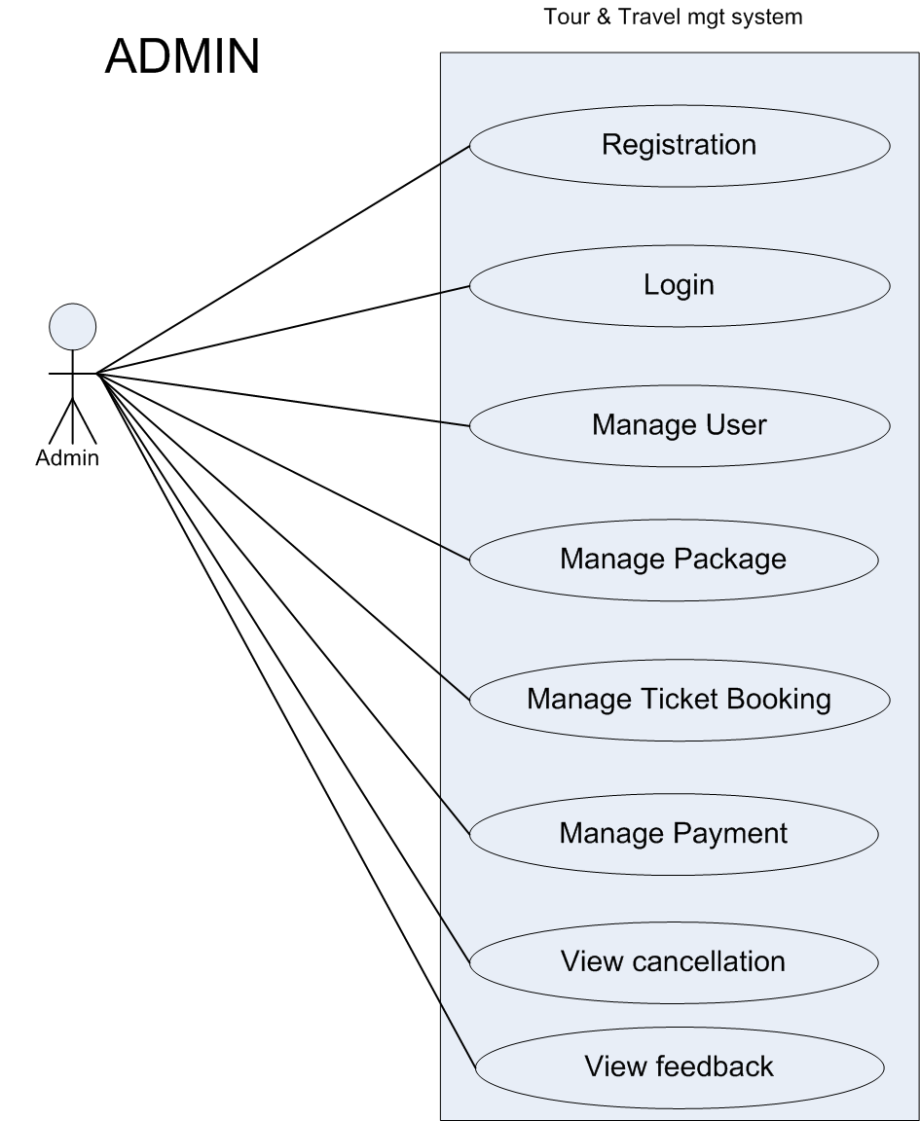

**Figure 4.3**

**USE CASE DESCRIPTION:-**

A use case diagram in the Unified Modeling Language (UML) is a type of behavioral diagram defined by and created from a Use-case analysis. Its purpose is to present a graphical overview of the functionality provided by a system in terms of actors, their goals (represented as use cases), and any dependencies between those use cases. Use case diagrams overview the usage requirements for a system.  They are useful for presentations to management and/or project stakeholders, but for actual development you will find that use cases provide significantly more value because they describe "the meat" of the actual requirements. The main purpose of a use case diagram is to show what system functions are performed for which actor.

Roles of the actors in the system can be depicted. Interaction among actors is not shown on the use case diagram. This use case starts when the actor does something. An actor always initiates use Cases. The use case should describe what the actor does and what the system does in response. The use case should describe what happens inside the system, but not how or why. If information is exchanged, be specific about what is passed back and forth. It should be phrased in the form of a dialog between the actor and the system. If this interaction is essential to a coherent description of the desired behavior, perhaps the system or use case boundaries should be re-examined. Alternatively, interaction among actors can be part of the assumptions used in the use case.

**4.2 ACTIVITY DIAGRAM:-**

An activity diagram is a simple and intuitive illustration of what happens in a workflow, what activities can be done in parallel, and whether there are alternative paths through the workflow. Activity diagrams represent the business and operational work flows of a system. An Activity diagram is a dynamic diagram that shows the activity and the event that causes the object to be in the particular state. Activity diagrams can show activities that are conditional or parallel.

Activity diagrams are used in process modeling and analysis of requirements stages of UML. Activity diagrams should be used in conjunction with other modeling techniques such as interaction diagrams and state diagram. The main reason to use activity diagrams is to model the work flow behind the system being designed. Activity Diagrams are also useful for analyzing a use case by describing what actions need to take place and when they should occur, describing a complicated sequential algorithm, and modeling applications with parallel processes.

Although UML activity diagrams could potentially model the internal logic of a complex operation it would be far better to simply rewrite the operation so that it is simple enough that you don’t require an activity diagram.

**4.3 Sequencial Diagram:**

A sequence diagram in a Unified Modeling Language (UML) is a kind of interaction diagram that shows how processes operate with one another and in what order. It is a construct of a Message Sequence Chart. A sequence diagram shows object interactions arranged in time sequence. It depicts the objects and classes involved in the scenario and the sequence of messages exchanged between the objects needed to carry out the functionality of the scenario.

Sequence diagrams typically (but not always), are associated with use case realizations in the Logical View of the system under development.A sequence diagram shows, as parallel vertical lines (lifelines), different processes or objects that live simultaneously, and, as horizontal arrows, the messages exchanged between them, in the order in which they occur. This allows the specification of simple runtime scenarios in a graphical manner.

**Figure 4.4**

**Figure 4.5**

**Figure 4.6**

**4.6 E-R Diagram:-**

**Figure 4.7**

**4.7 CLASS DIAGRAM:-**

A UML class diagram describes the object and information structures used by your application, both internally and in communication with its users. It describes the information without reference to any particular implementation. Its classes and relationships can be implemented in many ways, such as database tables, XML nodes, or compositions of software objects.

The class diagram is the main building block of [object oriented](http://en.wikipedia.org/wiki/Object_oriented) modelling. It is used both for general [conceptual modelling](http://en.wikipedia.org/wiki/Conceptual_model) of the systematics of the application, and for detailed modelling translating the models into [programming code](http://en.wikipedia.org/wiki/Programming_code). Class diagrams can also be used for [data modeling](http://en.wikipedia.org/wiki/Data_modeling).The classes in a class diagram represent both the main objects, interactions in the application and the classes to be programmed.

[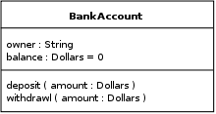](http://en.wikipedia.org/wiki/File:BankAccount1.svg)

classes are represented with boxes which contain three parts:

* The upper part holds the name of the class
* The middle part contains the attributes of the class
* The bottom part gives the methods or operations the class can take or undertake

In the design of a system, a number of classes are identified and grouped together in a class diagram which helps to determine the static relations between those objects. With detailed modeling, the classes of the conceptual design are often split into a number of subclasses.

In order to further describe the behavior of systems, these class diagrams can be complemented by [state diagram](http://en.wikipedia.org/wiki/State_diagram) or [UML state machine](http://en.wikipedia.org/wiki/UML_state_machine).

**Members**

UML provides mechanisms to represent class members, such as attributes and methods, and additional information about them.

Visibility To specify the visibility of a class member (i.e., any attribute or method) these are the following notations that must be placed before the member's name:[[3]](http://en.wikipedia.org/wiki/Class_diagram" \l "cite_note-HOL07-3)

"+" Public

"-" Private

"#" Protected

"~" Package

"/" Derived

"\_" Static

**Scope**

The UML specifies two types of scope for members: *instance* and *classifier*

**Classifier members** are commonly recognized as “static” in many programming languages. The scope is the class itself.

* + Attribute values are equal for all instances
  + Method invocation does not affect the instance’s state
* **Instance members** are scoped to a specific instance.
  + Attribute values may vary between instances
  + Method invocation may affect the instance’s state (i.e., change instance’s attributes



**Figure 4.8**

**Data Flow Diagram:-**



5 SYSTEM TESTING

Testing is vital to the success of the system. System testing makes a logical assumption that if all parts of the system are correct, the goal will be successfully achieved. In the testing process we test the actual system in an organization and gather errors from the new system operates in full efficiency as stated. System testing is the stage of implementation, which is aimed to ensuring that the system works accurately and efficiently.

In the testing process we test the actual system in an organization and gather errors from the new system and take initiatives to correct the same. All the front-end and back-end connectivity are tested to be sure that the new system operates in full efficiency as stated. System testing is the stage of implementation, which is aimed at ensuring that the system works accurately and efficiently.

The main objective of testing is to uncover errors from the system. For the uncovering process we have to give proper input data to the system. So we should have more conscious to give input data. It is important to give correct inputs to efficient testing.

Testing is done for each module. After testing all the modules, the modules are integrated and testing of the final system is done with the test data, specially designed to show that the system will operate successfully in all its aspects conditions. Thus the system testing is a confirmation that all is correct and an opportunity to show the user that the system works. Inadequate testing or non-testing leads to errors that may appear few months later. This will create two problems

Time delay between the cause and appearance of the problem.

The effect of the system errors on files and records within the system.

The purpose of the system testing is to consider all the likely variations to which it will be suggested and push the system to its limits.

The testing process focuses on logical intervals of the software ensuring that all the statements have been tested and on the function intervals (i.e.,) conducting tests to uncover errors and ensure that defined inputs will produce actual results that agree with the required results.

Testing has to be done using the two common steps Unit testing and Integration testing.

In the project system testing is made as follows:

The procedure level testing is made first. By giving improper inputs, the errors occurred are noted and eliminated.

This is the final step in system life cycle. Here we implement the tested error-free system into real-life environment and make necessary changes, which runs in an online fashion. Here system maintenance is done every months or year based on company policies, and is checked for errors like runtime errors, long run errors and other maintenances like table verification and reports.

**Introduction**

The most important phase in system development life cycle is system testing. The number and nature of errors in a newly designed system depends on the system specifications and the time frame given for the design.

A newly designed system should have all the subsystems working together, but in reality each subsystems work independently. During this phase, all the subsystems are gathered into one pool and tested to determine whether it meets the user requirements.

Testing is done at two level -Testing of individual modules and testing the entire system. During the system testing, the system is used experimentally to ensure that the software will run according to the specifications and in the way the user expects. Each test case is designed with the intent of finding errors in the way the system will process it.

Testing plays a very critical role in determining the reliability and efficiency of software and hence is a very important stage in software development. Software testing is done at different levels. They are the unit testing and system testing which comprises of integration testing and acceptance testing.

**4.2 TYPES OF TESTING**

**Unit Testing**

This is the first level of testing. The different modules are tested against the specifications produced during the integration. This is done to test the internal logic of each module. Those resulting from the interaction between modules are initially avoided. The input received and output generated is also tested to see whether it falls in the expected range of values. Unit testing is performed from the bottom up, starting with the smallest and lowest modules and proceeding one at a time.

The units in a system are the modules and routines that are assembled and integrated to perform a specific function. The programs are tested for correctness of logic applied and detection of errors in coding. Each of the modules was tested and errors are rectified. They were then found to function properly.

**Integration Testing**

In integration testing, the tested modules are combined into sub-systems, which are then tested. The goal of integration testing to check whether the modules can be integrated properly emphasizing on the interfaces between modules. The different modules were linked together and integration testing done on them.

**Validation Testing**

The objective of the validation test is to tell the user about the validity and reliability of the system. It verifies whether the system operates as specified and the integrity of important data is maintained. User motivation is very important for the successful performance of the system.

All the modules were tested individually using both test data and live data. After each module was ascertained that it was working correctly and it had been "integrated" with the system. Again the system was tested as a whole. We hold the system tested with different types of users. The System Design, Data Flow Diagrams, procedures etc. were well documented so that the system can be easily maintained and upgraded by any computer professional at a later

**System Testing**

The integration of each module in the system is checked during this level of testing. The objective of system testing is to check if the software meets its requirements. System testing is done to uncover errors that were not found in earlier tests. This includes forced system failures and validation of total system as the user in the operational environment implements it. Under this testing, low volumes of transactions are generally based on live data. This volume is increased until the maximum level for each transactions type is reached. The total system is also tested for recovery after various major failures to ensure that no data are lost during the breakdown.

**6 IMPLEMENTATION**

**6.1 Coding of Home Page**

<html xmlns="http://www.w3.org/1999/xhtml">

<head runat="server">

<title>Design Demo</title>

<style type="text/css">

body { margin:0px; }

#fulldiv {

width:100%; height:auto; margin:0px;

background-image:url(images/bg-pattern.jpg) }

#bodydiv {

border:1px solid #000000; height:auto; width;70%;

margin-left:150px; margin-right:150px; background-color:#FFFFFF; }

#head { height:auto; width:100%; }

#tophead { height:30px; width:100%; }

.acls {

font-family: 'Roboto', sans-serif; background-color:#00B895;

text-decoration:none; text-transform: uppercase;

padding:7px 15px; float:right; font-size:.8em;

transition: 0.5s ease; -o-transition: 0.5s ease;

-webkit-transition: 0.5s ease; border-radius: 4px 4px;

margin-right:10px; color:#fff: }

.acls a

{

color:#fff;

text-decoration:none;

font-family: 'Roboto', sans-serif; }

#leftdiv{ width:60%; height:100%; float:left; margin:0px; }

#rightdiv { height:100%; width:40%; float:left;}

#menudiv { height:80px; width:100%; background-image:url("images/000.jpg");}

#menuleft1{ height:100%; width:710px; float:left; }

#menuright1{ height:100%; width:332px; float:left; }

#tbl{ height:auto; width:300px; background-color:#009966; margin:15px; margin-left:30px;}

.bcls{

height:99%; float:left; border:1px thin #000000;

width:130px; text-align:center; background-color:}

.aclsa{

text-align:center; font: bold 16px/80px Arial, Helvetica, sans-serif; text-decoration: none;text-transform: uppercase; text-align:center; margin-top:45px;color:Black;}

#demodiv:hover{ background-color:#45B39E;}

.bcls1 {height:39px; width:80px; float:left; margin-left:35px;}

.aclsa1{

font: bold 16px/30px Arial, Helvetica, sans-serif; text-align:center; text-decoration: none; font:Georgia, "Times New Roman", Times, serif;}

/\*----special-grid------\*/

.special-grid { float: left; width: 32%; margin-left:100px; text-align: center;}

.special-grid img{width:100%; margin-top:30px;}

.special-grid a{ text-transform: uppercase; font-size: 1.2em; font-family: 'Roboto', sans-serif;

color:#5F5F5F; transition: 0.5s ease; -o-transition: 0.5s ease;

-webkit-transition: 0.5s ease; padding: 0.3em 0;

display: block; text-decoration:none; }

.special-grid a:hover{color: #009175;}

.spe-grid{margin: 0px; }

.specials-grids { padding: 0 0;}

.lb { font-size:large; color:White; font-style:oblique; }</style>

<asp:ContentPlaceHolder id="head" runat="server">

</asp:ContentPlaceHolder>

</head><body>

<form id="form1" runat="server">

<div id="fulldiv" > <div id="bodydiv">

<div id="Div1">

<div id="tophead">

<div id="leftdiv">

<div id="DIV2" runat="server" style=" height:50px; width:100%;"></div> </div>

<div id="rightdiv">

<div class="acls"><a href="SignUp.aspx" >Sign Up</a></div>

<div id="abt" class="acls"><a href="Aboutus.aspx" >About Us</a></div>

<div class="acls"><a href="registration.aspx" >Log in</a></div> </div>

</div>

<div id="menudiv">

<div id="menuleft1">

<div id="demodiv" class="bcls"><a href="Home.aspx"

class="aclsa" >Home</a></div>

<div id="demodiv" class="bcls"><a href="ppackage.aspx"

class="aclsa" >Package</a> </div>

<div id="demodiv" class="bcls"><a href="#"

class="aclsa" >Booking</a></div>

<div id="demodiv" class="bcls"><a href="contactus.aspx"

class="aclsa" >Contact Us</a></div>

<div id="demodiv" class="bcls"><a href="Cfeedback.aspx"

class="aclsa" >Feedback</a></div>

</div>

<div id="menuright1">

<table id="tbl">

<tr><td><input type="text" name="subject" id="subject" placeholder="Search Your Place" style=" height:30px; width:240px;" /></td>

<td><a href="ppackage.aspx"><img src="picture/search.png" id="img1" ></img></a></td> </tr> </table></div>

</div></div>

<div id="mainbody" runat="server" style=" height:640px; width:100%; border: solid 1px #000000; background-image:url(images/); ">

<asp:ContentPlaceHolder id="ContentPlaceHolder1" runat="server">

</asp:ContentPlaceHolder></div>

<div id="footer" style=" height:210px; width:100%; ">

<div id="lower" style=" background-color:#66CC99; height:210px; width:100%;">

<center>

<div class="specials"><div class="wrap">

<div class="specials-grids">

<div class="special-grid">

<img src="images/grids-img1.jpg" title="image-name" />

<a href="#">Latest Plans</a> </div>

<div class="special-grid">

<img src="images/grids-img2.jpg" title="image-name" />

<a href="#">Pre Plans</a></div>

</div></div></div>

</center></div></div></div></div> </form>

</body></html>

**6.2 Connection Class Coding :-**

public class Connection

{

public Connection() { }

private string str = "Data Source=.\\SQLEXPRESS;Initial Catalog=Tour;Integrated Security=true;";

public string execute\_record(string qry)

{ SqlConnection con = new SqlConnection();

con.ConnectionString = str;

con.Open();

SqlCommand cmd = new SqlCommand(qry, con);

cmd.ExecuteNonQuery();

con.Close();

return "y";

}

public DataTable read\_record(string qry)

{ SqlConnection con = new SqlConnection();

con.ConnectionString = str;

DataTable dt = new DataTable();

SqlDataAdapter sda = new SqlDataAdapter(qry, con);

sda.Fill(dt);

return dt;

}

}

**6.3 Slider Effect Code**

< script type="text/javascript" src="jquery.min.js"></script>

<script type="text/javascript" src="responsiveslides.min.js"></script>

<script type="text/javascript">

// You can also use "$(window).load(function() {"

$(function () {

// Slideshow 1

$("#slider1").responsiveSlides({

maxwidth: 1200, speed: 1000

}); }); </script>

**6.4 Session Code**

if (pas1 == passdata1 && pas2 == passdata2)

{

Label1.Visible = true;

Label1.Text = "Got it";

Session["user"] = cusaddr.Text;

Session["pwd"] = cuspass.Text;

Response.Redirect("ticketbook.aspx"); }

else {

Label1.Visible = true;

Label1.Text = "Email or password are wrong"; }

**}**

**//**On second pageLabel12.Text = Session["user"].ToString();

**6.5 Different Methods used:-**

Response.Redirect("pagename”?url=value); //1st page

Request.QueryString["url"].ToString() //2nd page

**6.6 Code of filling drop down list**

protected void ddl2\_SelectedIndexChanged(object sender, EventArgs e)

{

DataTable dt3 = new DataTable();

string qry = "select \* from place where c\_id='" + ddl2.SelectedValue + "' ";

dt3 = cc.read\_record(qry);

ddl3.Items.Clear();

ddl3.Items.Add("Select Place");

ddl3.DataSource = dt3;

ddl3.DataTextField = "place\_name";

ddl3.DataValueField = "place\_id";

ddl3.DataBind();

}

**SCREENSHOTS**

**Home Page**

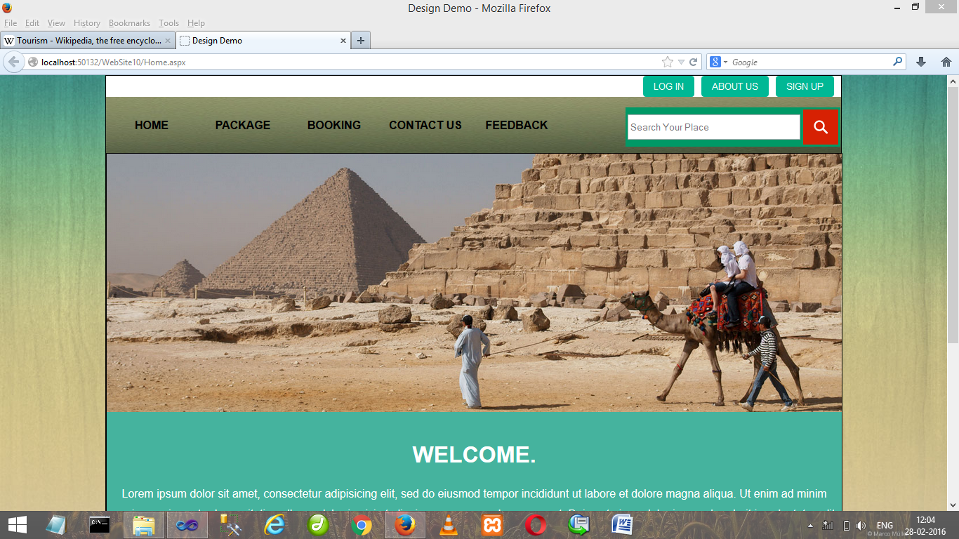

**Registration page**

**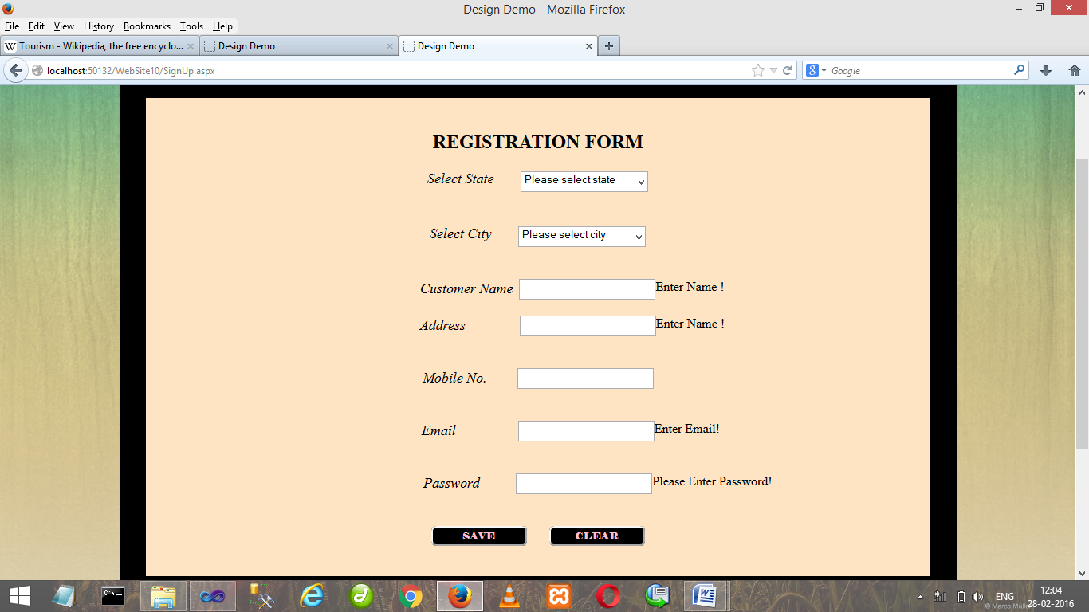**

**Package page**

**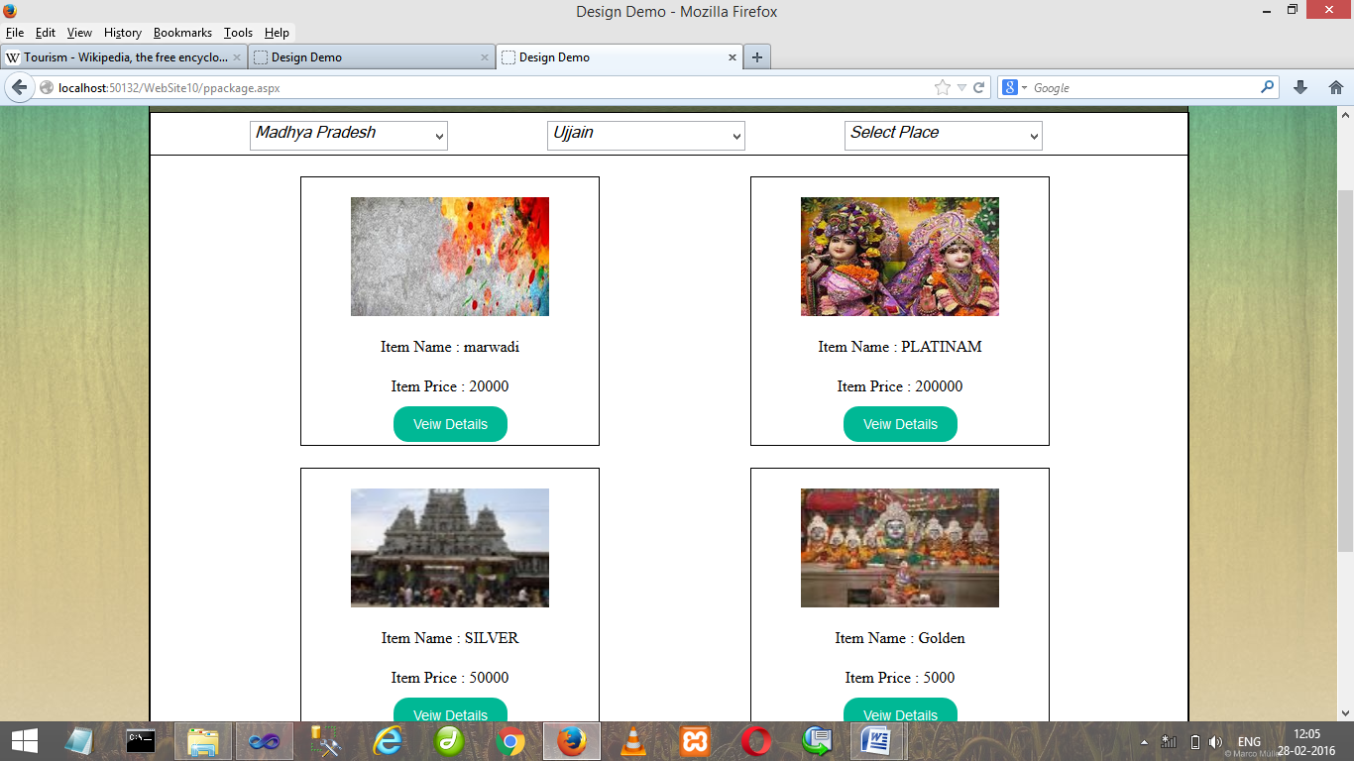**

**TicketBooking Page**

**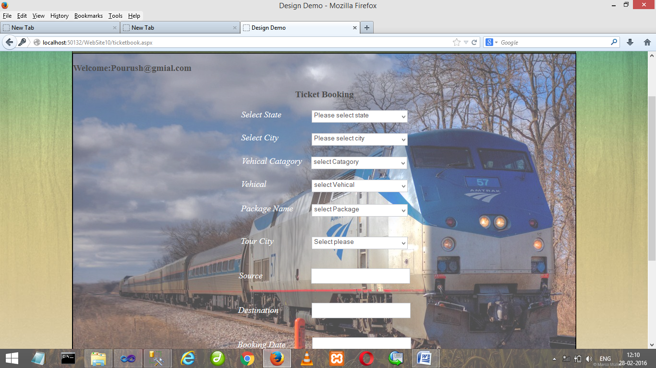**

**Admin page**

**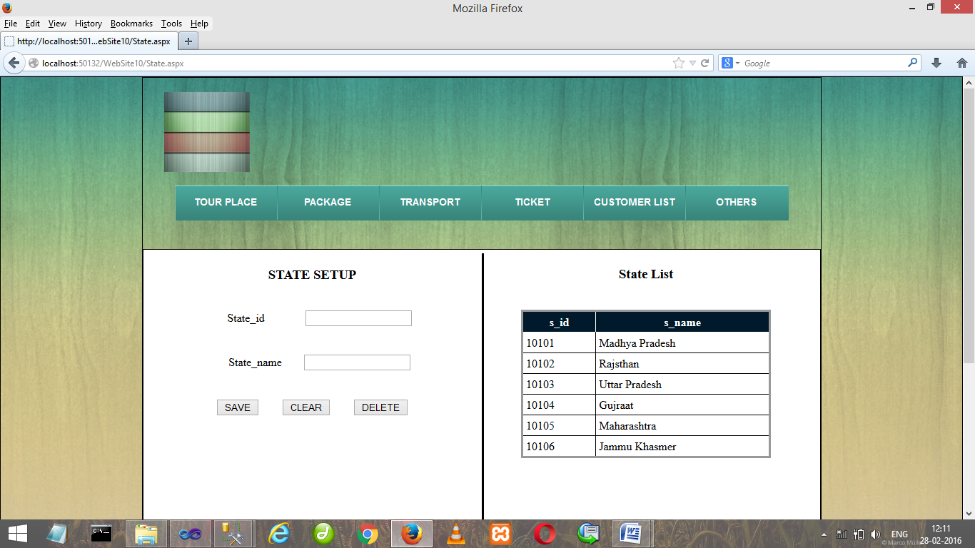**

**Contact Us**

**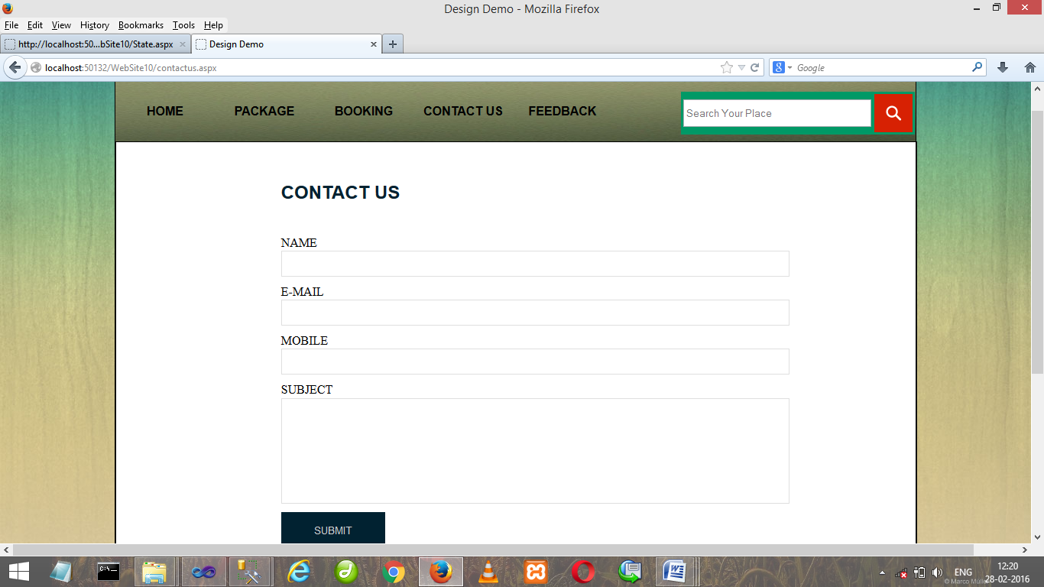**

**7 CONCLUSION AND FUTURE WORK**

**7.1 Conclusion:-**

At the last we tried to develop a good tour management website , where a customer can easilyfind its interesting place to travel on the basis of suitable package, time , relevant price. customer can contact us easily. Packages are available for the comfortability of customer and a personal guide is also helpfull for user .

We hope everybody enjoy our Tour Management Website and will give positive feedback.

**7.2 Future Work**

**#** Membership can be Added.

# Management Plan can extent upto world level.

# Payment can be make comfortable.

**8 REFRENCES**

**8.1 websites**

**1** http://www.w3schools.com

**2** <http://www.tutorialspoint.com>

**3** <http://www.java2SE.com>

**4** http://www.codeproject.com